**Knightfall Season 3: Release Date and other details!** 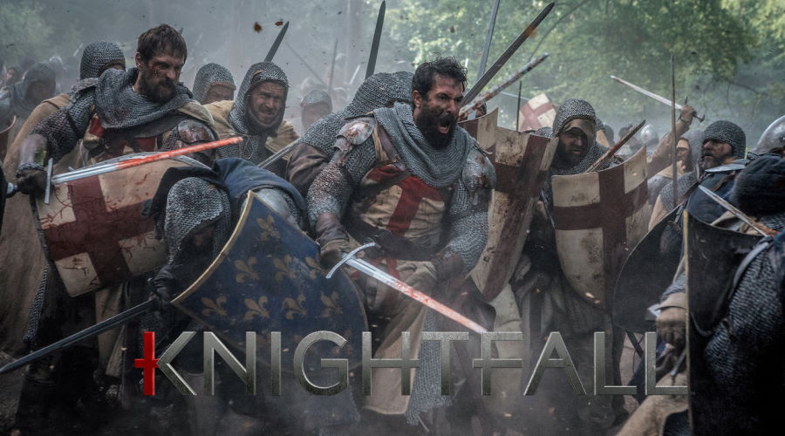

**Knightfall**, a Czech-American historical fiction drama *television series* filmed in Prague, Czech Republic, and Dubrovnik, Croatia. It was created by Don Handfield and Richard Rayner. It was produced collectively by Michael Wray, Gideon Amir, and Nina Heyns.

**Knightfall Season 3: Release Date**

It was announced in January 2016 by history that **Knightfall** has been picked up for a 10-episode television series. Then **Season** 1 trailer was released on February 1, 2017, continuing the **season release** on December 6, 2017. On August 13, 2018, the series was renewed for a second season by history which was **released** on March 25, 2019. Later in May 2020, an announcement has been made of the **series cancellation**. Anticipated reasons are the drop in viewers of **Season** 2 despite trying to improve Season 2 after an average review of Season 1. So, the creators and the distributors are not willing to create another season. But if the viewers and the fan base of the series do some campaign type of thing to save the show then there's a possibility of the creation of **Knightfall Season 3** though that seems to be highly unlikely. But nothing's predictable because it's up to the creators and showrunners of the series whether they would like to revive the show for another season thinking of trying once more with something different that can lead to an increment in the viewership of the show.

**Knightfall Season 3: Probable Plot and Cast**

If the creator agrees to create another season in the future then the protagonists of the show are likely to repeat their roles. Apart from that, there may be few more additional characters but nothing is predictable as of now since the show has been canceled by the creators. Let's recap a few characters of the show who appeared in the previous seasons of the series.

**Landry de Lauzon** played by Tom Cullen- Harry Webster plays the role of young Landry in the earlier season. He's a senior brother of the Knights Templar having a noble and brave temperament. He starts his service with the Templars being Godfrey's Squire. Squires are the people who're mentored and guided by Godfrey into a skillful warrior monk. Landry observes the conquest of the Holy Land by the Saracens, the failure of the Crusade, and the loss of the most-valuable relic in all of Christendom: The **Holy Grail**, after the Siege of Acre. Fifteen years later after **Godfrey** was killed, he becomes master and Commander of the Paris Temple. On further inquiry, it was unveiled that Grail is in France. So, he goes on the journey to unveil the reasons for his master's death and locate the Grail. 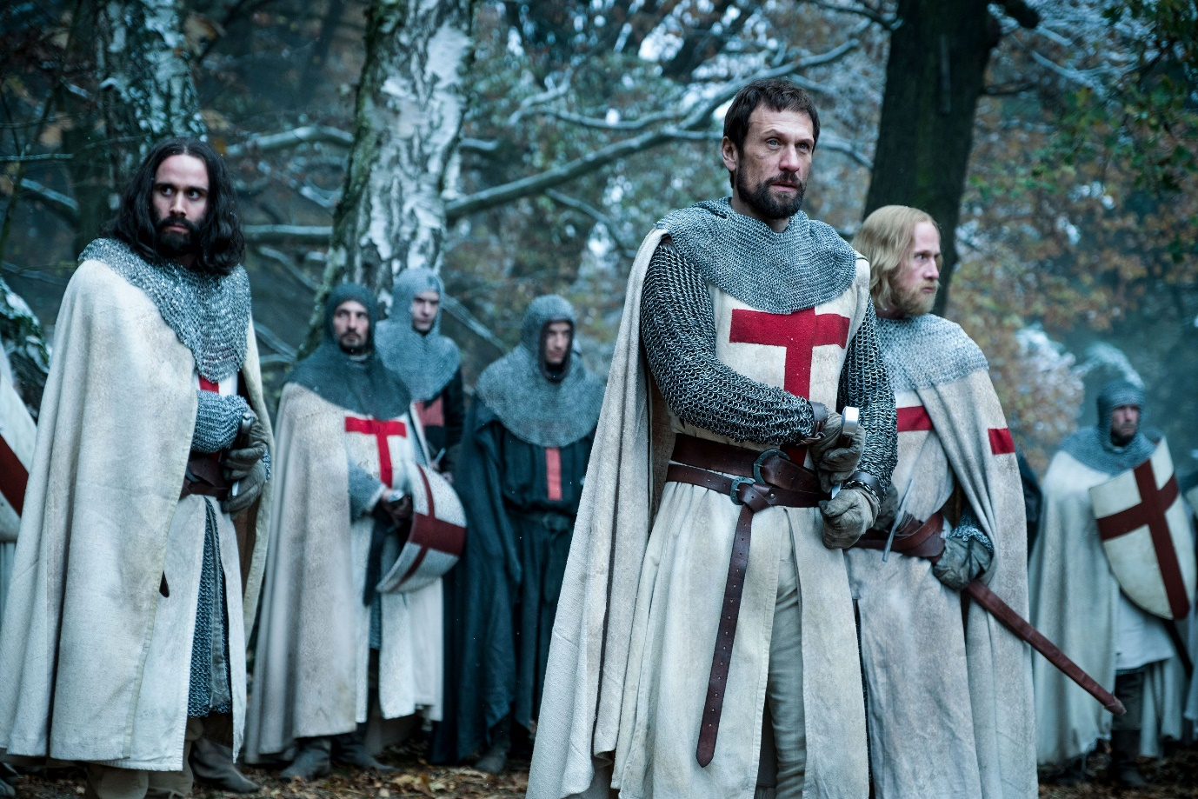

**Pope Boniface VIII** played by Jim Carter- He's a helpful kind-hearted person. He's a great religious leader who doesn't like corruption in the medieval world. He's valued as a holy leader by the Templar Knights. His orders are kept in high regard by the **Templar Knights** and everyone does follow that without questioning him. He appoints **Landry** as the new master and commander of the Paris Temple and puts belief in him for the duty he's assigned of locating the **Holy Grail** and finding the killer of Godfrey. He hopes to use the Holy Grail to reclaim the Holy land.

Gawain played by Padraic Delaney- He's the greatest swordsman of the Templar Order who gets sabotaged by a leg injury which he got while he was trying to protect Landry in the Siege of Acre. After Godfrey's assassination, when Landry takes the charges as the new master, he assigns him the task of tutoring and training future knights. Since he's sabotaged by the leg injury so he'll gain the most from the Holy Grail because of its capabilities to heal the wounded. So, he wishes for Landry to be able to locate the Holy Grail.

Tancrede de Hauteville played by Simon Merrells- He's a brave Templar who sees himself as the successor of Godfrey, the Master, and Commander of the Paris. But when Landry was assigned that position, still he concedes to him and obeys his order. He's a very devoted person who was once married but he gave up his married life to join the Templars.

William de Nogaret played by Julian Ovenden- He's the advisor and right-hand of King Philip. He's keen on destroying the power of organized religion since his parents were burnt for practicing Catharism. He's secretly in love with Isabella.

**Queen Joan** played by Olivia Ross- She's the wife of King Philip, so she's the queen of France. She's a friend of Landry after he saved her and king Philip from the brigands. She fell in love with Landry and secretly she's pregnant with his child which's not known to her husband.

**King Philip** played by Ed Stoppard- He's the king of France and a friend of Landry after he saved him and his wife from the brigands.

**Princess Isabella** played by Sabrina Bartlett (season 1) and Genevieve Gaunt (season 2)- She's the daughter of Queen Joan and King Philip.

Parsifal played by Bobby Schofield- He's a youthful peasant with a decent personality who's brave enough to fight for the right. He was living happily with his wife, Marie until Godfrey's killer kills his wife. And thus, when he was offered to join the templars by Landry, he accepts so that he can take vengeance for his wife's murder by slaughtering the murderer.

Adelina played by Sarah-Sofie Boussnina- She's a destitute thief who's rescued by Landry in her childhood. She's somehow associated with the concealed forces encapsulating the Holy Grail.

Prince Louis of France played by Tom Forbes- He's the eldest son and heir of King Philip and Queen Joan.

Master Talus played by Mark Hamil

As we saw in the characters' explanation, **Knightfall Season 3** is likely to revolve around **Landry** trying to find the **Holy Grail** and **Godfrey**'s assassin. Apart from that Isabella's marriage can be an important storyline for the creators which will bring many twists and turns to the show.